AGENTSPACE
Technical Assessment: Annuities Quoting Platform Build

What This Is
This is a timed, 2-hour technical trial. It’s designed to assess how you think, how fast you move, how you break down a complex problem you’ve never seen before, and how effectively you use the tools available to you (especially AI).
This is supposed to be impossible to fully complete. Just do your best. A well-reasoned incomplete build beats a rushed complete one.
You’re going to take a real annuity product database and design a working quoting system from scratch — schema, backend architecture, and a simple front-end concept that an insurance agent could actually use.
If you don’t know what an annuity is, go figure it out. That’s part of the test.

The Setup
• Time limit: 2 hours from the moment you start. The clock is running.
• Questions: If you get stuck or need clarification, ask. You’ll get a response as fast as possible.
• AI is encouraged: Use Claude, ChatGPT, Cursor, whatever you want. This isn’t a test of whether you can do everything manually — it’s a test of how effectively you leverage AI to solve complex problems fast.
• Tech stack: Use whatever languages, frameworks, and tools you’re fastest with.

The Problem
You’re building a replacement for Annuities Genius, an annuity quoting tool used by insurance agents. You have access to the underlying product database. Your job is to design the schema, backend architecture, and front-end for a system that replicates (and improves on) this quoting functionality — an internal tool that lets agents query annuity products and get accurate quotes back.
You do not need to have live data flowing through the system. Your schema and architecture should be designed based on the Annuities Genius reference (Loom video) and the product database (spreadsheet). Think of it this way: you’re building the dock — the ship is coming. When the full data feed goes live, we just point it at your system and it works.

The Data
We’ve licensed a comprehensive fixed annuity database from one of the top annuity data providers in the industry. This is the same underlying data that powers tools like Annuities Genius.
The spreadsheet has 10 tables with hundreds of columns. You need to dig through it, figure out what’s important for quoting, what connects to what, and design a system that makes sense of it all. Not every column matters — part of the challenge is figuring out which ones do.

Resources
Review these before you write a single line of code:
• Product Database (essential): ATTACHED IN THE EMAIL

• Annuities Genius Walkthrough (essential): https://drive.google.com/file/d/1OCB4LlH7v6BycrJ0xPqbpJeNUgO0qk5o/view?usp=sharing

Recommended Approach
1. Research first. Watch the Loom, dig through the spreadsheet, and understand how the data is structured before you touch any code.
2. Design the schema. Figure out which pieces of the Beacon data matter for a quoting engine and how to structure them cleanly.
3. Build the backend architecture. Design the logic that takes basic inputs (age, premium, product type, etc.) and returns matching quotes.
4. Create a simple UI concept. Something a non-technical insurance agent could actually use. Doesn’t need to be pretty — needs to be clear.
Bonus: If you’re making good time, add an AI-assisted natural language query layer — something like “Show me the best 5-year MYGA for a 62-year-old with $100K in non-qualified funds.”

How You’ll Be Evaluated
We’re looking at how well you understood the data and translated it into a clean, logical schema. We care about the soundness of your backend architecture and whether the data flow makes sense. If you get to a UI, we want to see something a non-technical insurance agent could actually use. Your process doc matters just as much as the build — clear thinking and smart trade-offs go a long way. And if you manage to get a natural language query layer working, that’s a standout bonus.

Where you stand:
• Schema + architecture doc
• Add a usable UI
• NLP query layer on top = bonus

What to Submit
When your 2 hours are up, submit two things:

1. A deployed app link
Something that can be seen and interacted with in a browser. Deploy anywhere (Vercel, Replit, Railway, etc.)
2. A process document (1–2 pages)
Cover four things: your approach and how you analyzed the data, your key schema and architecture decisions (and why), how you used AI and what worked, and what you’d do next with more time. Keep it tight.

What Stands Out
Creativity matters more than completeness. If you found a clever shortcut, used AI in a way that 10x’d your speed, or came up with an approach that’s better than the reference platform — that’s what we remember.

Good luck. Show us how you think.

SHAPE: (244, 12)

COLUMN DEFAULTS & DYPES:
# int64
FILE_NAME object
COLUMN_NAME object
IS_ID object
ORDINAL_POSITION int64
DATA_TYPE object
CHAR_MAX_LENGTH float64
NUM_PRECISION float64
NUM_SCALE float64
IS_NULLABLE object
DESCRIPTION object
NOTES float64
dtype: object

BASIC INFO:
<class 'pandas.core.frame.DataFrame'>
RangeIndex: 244 entries, 0 to 243
Data columns (total 12 columns):
# Column Non-Null Count Dtype
--- ------ -------------- -----
0 # 244 non-null int64
1 FILE_NAME 244 non-null object
2 COLUMN_NAME 244 non-null object
3 IS_ID 244 non-null object
4 ORDINAL_POSITION 244 non-null int64
5 DATA_TYPE 244 non-null object
6 CHAR_MAX_LENGTH 86 non-null float64
7 NUM_PRECISION 96 non-null float64
8 NUM_SCALE 96 non-null float64
9 IS_NULLABLE 244 non-null object
10 DESCRIPTION 244 non-null object
11 NOTES 0 non-null float64
dtypes: float64(4), int64(2), object(6)
memory usage: 23.0+ KB

ABLES & COLUMN COUNTS:

 | Column_Count | ID_Columns | Nullable_Count
FILE_NAME
beacon_client_fixed_Rates | 83 | 12 | 67
beacon_client_fixed_Contract_Contributions | 49 | 3 | 32
beacon_client_fixed_Waivers | 27 | 3 | 15
beacon_client_fixed_gmwb | 25 | 3 | 22
beacon_client_fixed_products | 15 | 2 | 11
beacon_client_fixed_age | 13 | 3 | 12
beacon_client_fixed_gmab | 10 | 3 | 7
beacon_client_fixed_bonuses | 7 | 3 | 5
beacon_client_fixed_death_benefits | 7 | 3 | 5
beacon_client_fixed_Withdrawals | 5 | 3 | 4
beacon_client_fixed_companies | 3 | 2 | 1

VARIABLES BY TABLE:

📁 beacon_client_fixed_age (13 columns)
PRODUCTID, MINANQ, MINAQ, MINONQ, MINOQ, MXANQ, MXAQ, MXAZNQ...
... and 5 more

📁 beacon_client_fixed_bonuses (7 columns)
productid, bonus_id, name, sequence, inception_date, closed_date, UNIQUEID

📁 beacon_client_fixed_companies (3 columns)
company_name, COMPANYID, UNIQUEID

📁 beacon_client_fixed_death_benefits (7 columns)
productid, name, sequence, benefit_id, sub_sequent_premium, partial_withdrawals, UNIQUEID

📁 beacon_client_fixed_gmab (10 columns)
name, sequence, closed_date, product_id, gmab_id, introduction_date, avail_when_added, target_anniversery_years...
... and 2 more

📁 beacon_client_fixed_gmwb (25 columns)
productid, name, sequence, closed_date, partial_withdrawals, introduction_date, gmwb_type, reqd_min_distributions...
... and 17 more

📁 beacon_client_fixed_products (15 columns)
PRODUCTID, name, closed_date, Company name, EXPDATE, INCDATE, PREMIUM_TYPE, WINAFTSURR...
... and 7 more

📁 beacon_client_fixed_Rates (83 columns)
PRODUCTID, company_name, urn_code, bandid, blockid, varid, schedid, product_name...
... and 75 more

📁 beacon_client_fixed_Waivers (27 columns)
productid, EXPDATE, ANN, BAIL, DEATH, DES_ANN, DES_BAIL, DES_DEATH...
... and 19 more

📁 beacon_client_fixed_Withdrawals (5 columns)
PRODUCTID, ANNFREEPCT, DES_MVA, UNIQUEID, WITHID

📁 beacon_client_fixed_Contract_Contributions (49 columns)
FOUR57, PENSION, PROFSH, DESCR, SEPIRA, FOUR01A, KEOGH, IRATR...
... and 41 more

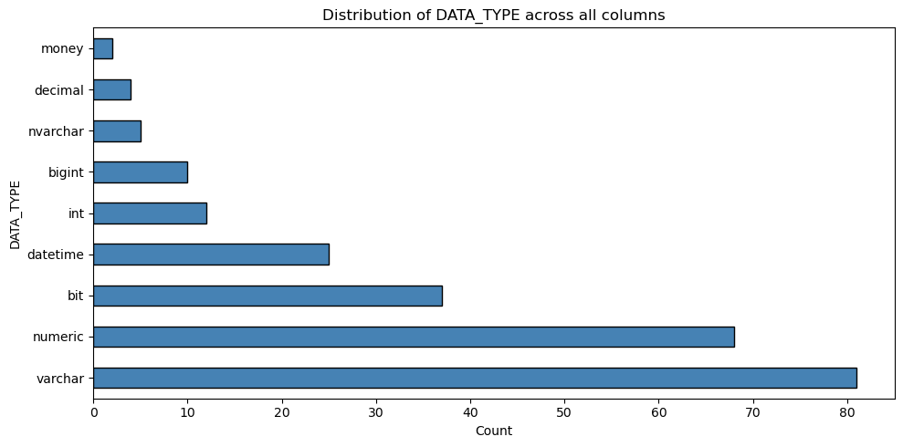

IS_NULLABLE distribution:
IS_NULLABLE
YES 181
NO 63
Name: count, dtype: int64

ID columns (IS_ID = Yes): 40

ID columns by table:
 | ID_Columns
FILE_NAME
beacon_client_fixed_Contract_Contributions | [PRODUCTID, CONTRIBID, UNIQUEID]
beacon_client_fixed_Rates | [PRODUCTID, bandid, blockid, varid, schedid, U...
beacon_client_fixed_Waivers | [productid, UNIQUEID, WAIVERID]
beacon_client_fixed_Withdrawals | [PRODUCTID, UNIQUEID, WITHID]
beacon_client_fixed_age | [PRODUCTID, UNIQUEID, AGEID]
beacon_client_fixed_bonuses | [productid, bonus_id, UNIQUEID]
beacon_client_fixed_companies | [COMPANYID, UNIQUEID]
beacon_client_fixed_death_benefits | [productid, benefit_id, UNIQUEID]
beacon_client_fixed_gmab | [product_id, gmab_id, UNIQUEID]
beacon_client_fixed_gmwb | [productid, gmwb_id, UNIQUEID]
beacon_client_fixed_products | [PRODUCTID, UNIQUEID]
Descriptive stats for numeric specification fields:

 | ORDINAL_POSITION | CHAR_MAX_LENGTH | NUM_PRECISION | NUM_SCALE
count | 244.000000 | 86.000000 | 96.000000 | 96.000000
mean | 23.594262 | 4214.453488 | 14.479167 | 1.093750
std | 21.649550 | 3990.364255 | 5.688361 | 1.414795
min | 1.000000 | -1.000000 | 1.000000 | 0.000000
25% | 6.000000 | 3.000000 | 10.000000 | 0.000000
50% | 16.000000 | 8000.000000 | 18.000000 | 0.000000
75% | 36.000000 | 8000.000000 | 18.000000 | 2.000000
max | 83.000000 | 8000.000000 | 19.000000 | 4.000000

Missing values in key columns:
FILE_NAME 0
COLUMN_NAME 0
DATA_TYPE 0
DESCRIPTION 0
dtype: int64

